# CHAPTER 3: SYSTEM ANALYSIS AND DESIGN

## 3.1 Introduction

This chapter presents the system analysis and design for the Patient Feedback Management System. It covers the system development methodology, feasibility study, data collection techniques, system requirements, data analysis, system specification, and both logical and physical designs. These components ensure a structured approach to system development, facilitating the design of a user-friendly, accessible, and efficient feedback system. The system is intended to improve the process of collecting, managing, and analyzing patient feedback in healthcare institutions, thereby improving service delivery and patient satisfaction.

## 3.2 System Development Methodology

## The development of this system follows a structured approach to ensure efficiency, accuracy, and ease of implementation. The chosen methodology is the Agile Software Development Methodology, which allows for flexibility, continuous feedback, and iterative improvements throughout the development cycle.

### Justification for Agile Methodology

## The Agile methodology was selected due to its adaptability to changing requirements, stakeholder involvement, and iterative nature. Given the dynamic needs of the system users, Agile ensures continuous improvements through multiple iterations. The key reasons for choosing Agile include:

## User-Centric Approach - The methodology enables active user involvement, ensuring that the system meets actual user needs.

## Flexibility and Adaptability - Changes and new features can be incorporated at any stage of development.

## Faster Development and Deployment - Agile facilitates incremental releases, reducing the time required to deliver a functional product.

## Improved Quality - Continuous testing and validation at each stage enhance system reliability and performance.

## Risk Management - Early detection of errors and quick resolution prevent major failures at later stages.

### Phases of the Agile Methodology

## The system development process will follow the following Agile phases:

#### Requirement Analysis and Planning

## Identify system requirements based on user needs and objectives.

## Prioritize features into a product backlog.

## Define user stories and expected functionalities.

#### System Design

## Develop a prototype or wireframes for visualization.

## Define the system architecture, database structure, and interface design.

## Ensure scalability and security considerations.

#### Development (Iterative Sprints)

## Implement core features in short, time-boxed iterations (sprints).

## Conduct regular reviews and gather feedback from stakeholders.

## Adjust system functionality based on feedback and emerging needs.

#### Testing and Quality Assurance

## Perform unit testing, integration testing, and user acceptance testing (UAT).

## Address bugs and optimize system performance.

## Ensure system meets functional and non-functional requirements.

#### Deployment and Integration

## Deploy a minimum viable product (MVP) for user evaluation.

## Monitor system performance and address issues.

## Ensure seamless integration with existing infrastructure if necessary.

#### Maintenance and Continuous Improvement

## Provide ongoing support, bug fixes, and security updates.

## Gather user feedback for future enhancements.

## Iterate on new features based on evolving needs

### Tools and Technologies

The development and deployment of the patient feedback system require a robust set of tools and technologies, categorized as follows:

#### Development Tools

Flutter SDK (Latest Stable Version) - Cross-platform mobile application development framework.

Dart Programming Language - Primary language for Flutter application development.

Android Studio / Visual Studio Code - IDEs for coding, debugging, and testing.

Git & GitHub - Version control and collaborative code management.

Figma - UI/UX design and prototyping tool.

Postman - API testing tool for backend integration.

#### Backend and Database Technologies

Firebase Firestore - NoSQL cloud database for real-time data storage and retrieval.

Firebase Authentication - Secure authentication service supporting multiple login methods.

Firebase Cloud Storage - Storage solution for media files and attachments.

Firebase Cloud Messaging (FCM) - Push notification service for real-time updates.

#### Hosting and Deployment

Google Firebase Hosting - Scalable hosting for the backend and database.

Google Play Console - Deployment platform for launching the mobile application.

#### Security and Networking

Secure HTTPS Protocol - Ensuring secure data transmission between users and the backend.

Google Play Services - For authentication, push notifications, and cloud integrations.

## 3.3 Feasibility Study

A feasibility study was conducted to determine the viability of implementing the Patient Feedback Management System. The study covered several aspects:

### Economic Feasibility

#### Cost Benefit Analysis

### The development of the system is cost-effective due to the use of open-source technologies such as Flutter and Firebase. This reduces licensing and hosting costs significantly. The implementation of automated feedback collection minimizes manual administrative efforts, reducing labor costs. The system reduces reliance on paper-based feedback forms, thereby cutting down on printing and storage costs. With enhanced efficiency in feedback management, hospitals and clinics can allocate resources more effectively, reducing operational costs in the long run.

#### Return on Investment

### By streamlining patient feedback management, healthcare facilities will improve service delivery, enhance patient satisfaction, and ultimately increase patient retention. The system also provides valuable analytics to help administrators make data-driven decisions, improving operational efficiency and long-term cost savings. The ability to track patient concerns and service quality over time will enable continuous improvements in healthcare service delivery, leading to higher patient trust and engagement.

### Technical Feasibility

### The system will be developed using Flutter for cross-platform compatibility and Firebase for cloud-based storage and authentication. These technologies provide a scalable, secure, and cost-effective solution while ensuring real-time data synchronization. The integration of cloud functions and serverless computing eliminates the need for extensive backend infrastructure, making development and maintenance efficient. Additionally, Firebase’s real-time database allows instant feedback storage and retrieval, ensuring timely responses from administrators. The system will incorporate push notifications to alert users about important updates and responses to feedback.

The mobile application will feature an intuitive UI with built-in form validation, voice-to-text feedback submission, and accessibility features such as screen reader support and high-contrast themes. Firebase Authentication will be used for secure login via email, Google authentication, and phone number verification.

### Operational Feasibility

The system aims to enhance patient engagement by allowing seamless feedback submission. The platform's intuitive interface ensures that patients can easily provide feedback in multiple formats, including text, voice recordings, and ratings. The system will support multiple languages to cater to diverse patient populations. Healthcare administrators can effectively analyze and respond to feedback through an organized dashboard. The system integrates role-based access control to manage different user levels securely, preventing unauthorized access to sensitive information. Training sessions will be conducted for healthcare providers and administrative staff to ensure smooth adoption of the system.

The system will include an automated feedback categorization feature using Natural Language Processing (NLP) to classify feedback into predefined categories such as service quality, wait times, and staff conduct. Additionally, it will allow administrators to flag urgent feedback for immediate action.

### Legal and Ethical Feasibility

The system complies with legal and regulatory frameworks governing healthcare data protection and patient privacy. Compliance with healthcare data regulations such as HIPAA, GDPR, and Kenya's Data Protection Act ensures that patient feedback is collected, stored, and processed securely.

**Legal considerations include**

*Data Protection Laws*

The system enforces strict encryption and anonymization measures to ensure compliance with international and local data privacy laws.

*Patient Consent*

Users must provide explicit consent before submitting feedback, ensuring ethical data collection practices.

*Access Control*

Role-based access mechanisms restrict unauthorized personnel from viewing or modifying sensitive feedback information.

*Retention and Deletion Policies*

Feedback data will be retained for a defined period in compliance with legal requirements and then securely deleted.

Additionally, legal agreements such as Terms of Service and Privacy Policies will be integrated into the platform to inform users about their rights and how their data is handled.

## 3.4 Requirements Elicitation

### Data Collection

To ensure the proposed patient feedback management system effectively addresses the critical challenges of usability, accessibility, and engagement, a comprehensive and meticulous data collection process was employed. By integrating a blend of qualitative and quantitative techniques, the study aimed to capture a holistic view of current feedback systems, uncover usability gaps, identify accessibility barriers, and determine preferred feedback methods. This approach was meticulously designed to gather insights that are not only relevant but also actionable for enhancing the patient feedback management system.

#### Interviews

Structured interviews were conducted with healthcare professionals, IT staff, and patients to gain deep insights into their experiences with current feedback systems. These interviews focused on:

*Ease of use*

How accessible and intuitive the current feedback systems are.

*Engagement challenges*

Reasons for low patient participation.

*Preferred feedback methods*

Text input, voice recordings, ratings, or checkboxes.

*Accessibility barriers*

Language, font size, and compatibility with assistive technologies.

*Security concerns*

Confidentiality and patient trust in feedback systems.

**Interview Questions**

1. What are the main challenges in the current patient feedback system?
2. How often do you receive patient feedback, and how is it handled?
3. What is your preferred method for collecting and managing patient feedback?
4. What improvements would you like to see in a new patient feedback system?
5. How important is real-time feedback in improving healthcare service delivery?
6. What security and confidentiality concerns do you have regarding patient feedback?
7. How do you currently analyze and act upon patient feedback?

#### Questionnaires

Surveys were administered both electronically and in paper format to reach a diverse group of patients and healthcare professionals. These structured questionnaires collected quantitative data on the effectiveness of current feedback systems and potential improvements.

**Key Areas Covered**

* Frequency of patient feedback submission.
* Preferred feedback submission methods (text, voice, ratings).
* Barriers to using current feedback systems.
* Desired features for a new system, such as multilingual support.
* Importance of anonymity in providing honest feedback.
* The role of incentives in increasing feedback participation.

**Sample Questions**

1. How frequently do you provide feedback on healthcare services?
2. What is your preferred feedback method? (Text, voice, ratings)
3. What challenges do you face when submitting feedback?
4. Would you prefer an online feedback system over paper-based methods? Why?
5. How important is anonymity in providing honest feedback?
6. What incentives would encourage you to provide more feedback?

#### Observation

Observational studies were conducted in healthcare settings to analyze real-world feedback collection processes. The observations aimed to identify usability gaps and validate findings from interviews and surveys.

**Key Observations (Based on Findings)**

*Low Patient Engagement*

Patients showed reluctance to provide feedback, mainly due to time constraints and usability issues.

Fear of negative consequences deterred some patients from giving honest feedback.

*Slow and Inefficient Feedback Processing*

Most feedback collection was manual, leading to delayed responses from healthcare providers.

No real-time tracking system was available to process feedback efficiently.

*Fragmented Feedback Storage*

Existing systems lacked a centralized database, making it difficult to analyze trends or track recurring patient concerns.

Accessibility Barriers

Elderly patients and non-native speakers struggled with feedback submission due to language barriers and small font sizes.

*Security and Confidentiality Concerns*

Some patients avoided providing feedback due to concerns about privacy and data protection.

### Sampling Techniques

To ensure diverse and representative feedback, stratified sampling was employed. This method ensured that key groups—patients, healthcare professionals, and IT staff—were adequately represented.

**Determination of Sample Size**

A total of 50 respondents were selected based on feasibility and project scope. The sample was divided into:

*Patients (25 respondents)* - A mix of age groups, education levels, and medical backgrounds.

*Healthcare Professionals (15 respondents*) - Doctors and nurses actively involved in patient care.

*IT and Administrative Staff (10 respondents*) - Individuals managing feedback data and system security.

The sample size was chosen to balance data accuracy and feasibility, ensuring meaningful insights without overwhelming complexity.

### Relevance to System Requirements

The data collected through interviews, questionnaires, and observations directly informs the system's design and aligns with the research objectives and research questions.

|  |  |
| --- | --- |
| **Requirement** | **Justification from Findings** |
| User-Centered Design | Patients found existing systems difficult to use. |
| Multi-Platform Accessibility | Observations showed that not all patients had access to computers |
| Simplified Feedback Submission | Many patients preferred quick feedback methods like ratings and checkboxes. |
| Inclusive Design Features | Patients with disabilities faced challenges using current systems. |
| Real-Time Feedback Processing | Manual feedback collection caused delays in response times. |
| Security and Confidentiality | Patients avoided giving feedback due to privacy concerns. |

## 3.5 Data Analysis

To analyze the collected data, both qualitative and quantitative methods were applied. The findings were processed using Excel to calculate percentages, averages, and trends. The results are visualized using pie charts, bar graphs, and line graphs to highlight key insights regarding usability, accessibility, and engagement challenges in the current patient feedback systems.

### 3.5.1 Interview Analysis

Structured interviews with healthcare professionals, IT staff, and patients provided qualitative insights into usability challenges. The key responses were categorized, and their frequency was analyzed.

**Key Findings from Interviews:**

*Main Challenges in Current Feedback Systems*

From the 50 respondents interviewed, 20 cited usability issues such as complex forms and unclear instructions. Security concerns, including fear of data breaches, were raised by 15 participants. Additionally, 10 respondents noted the absence of real-time feedback options, while 5 participants highlighted accessibility barriers such as language limitations and difficulties for people with disabilities.

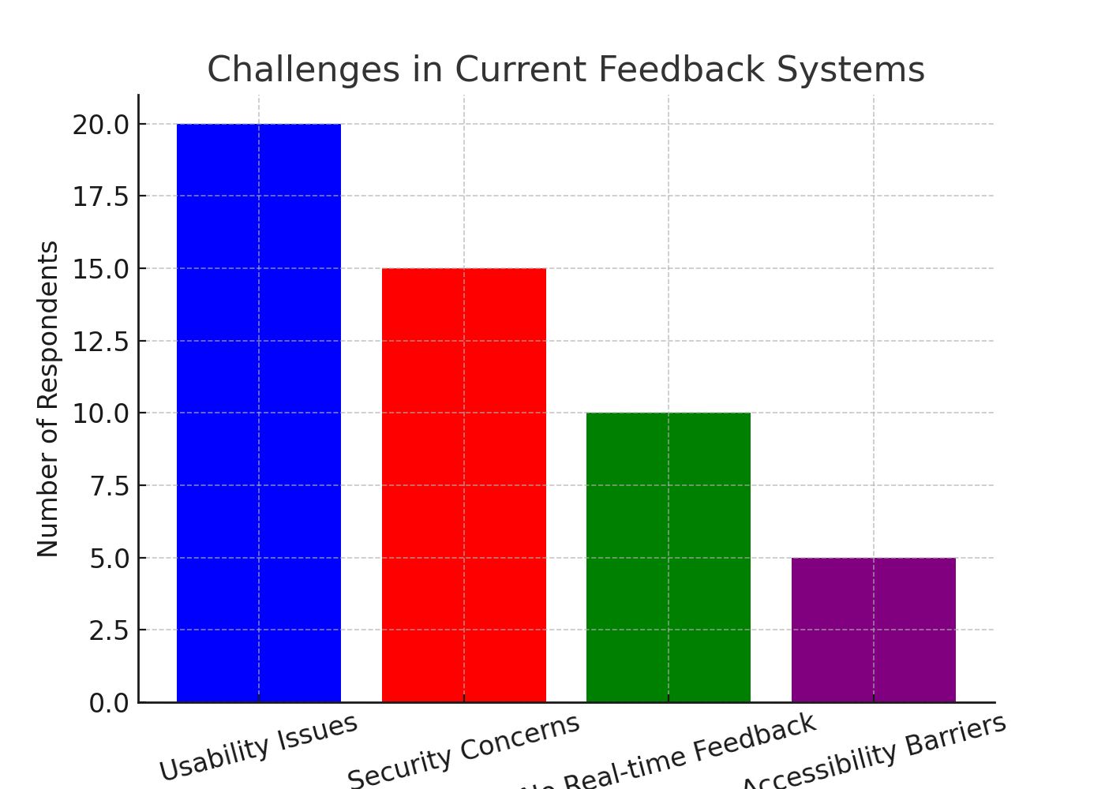

*Preferred Methods for Collecting Feedback*

Half of the respondents (25 out of 50) preferred mobile app-based feedback mechanisms due to their convenience and accessibility. Website-based forms were the second most preferred option, with 15 respondents choosing this method. Direct verbal feedback at healthcare centers was favored by 7 respondents, while 3 preferred the traditional paper-based feedback system.

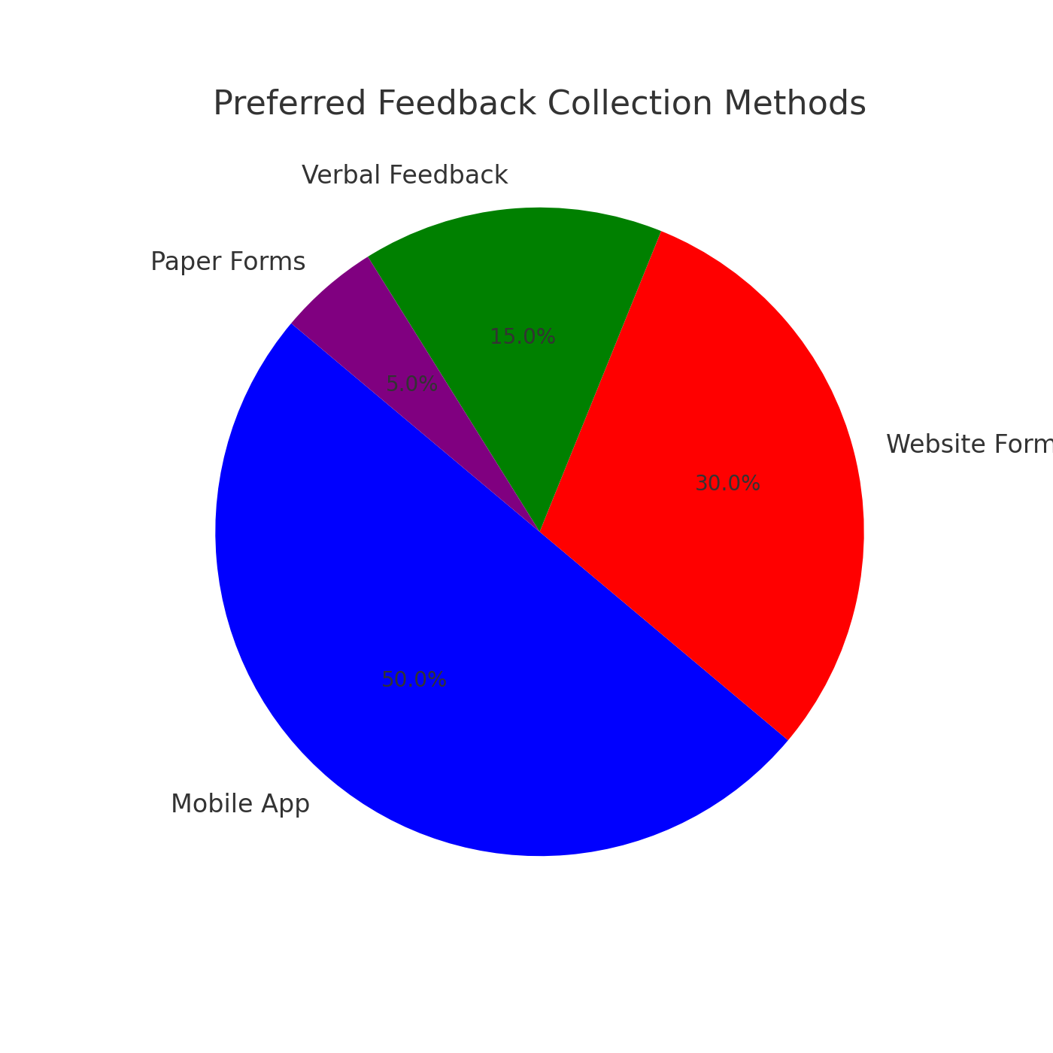

*Importance of Real-Time Feedback*

The majority of healthcare providers (35 out of 50) strongly agreed that real-time feedback plays a critical role in improving service delivery. An additional 10 respondents agreed with this sentiment, while the remaining 5 remained neutral. This indicates a high demand for a feedback system that allows instant responses and data analysis.

### 

### 3.5.2 Questionnaire Analysis

The questionnaire responses provided quantifiable data on patient and healthcare provider experiences with feedback systems**.**

**Key Findings from Questionnaires:**

*How Often Do Patients Provide Feedback?*

Among the 50 patients surveyed, 30 reported that they rarely provide feedback, while 12 stated that they do so occasionally. Only 5 patients frequently submit feedback, while 3 respondents admitted to never giving feedback at all. These numbers emphasize the low engagement in current feedback systems.

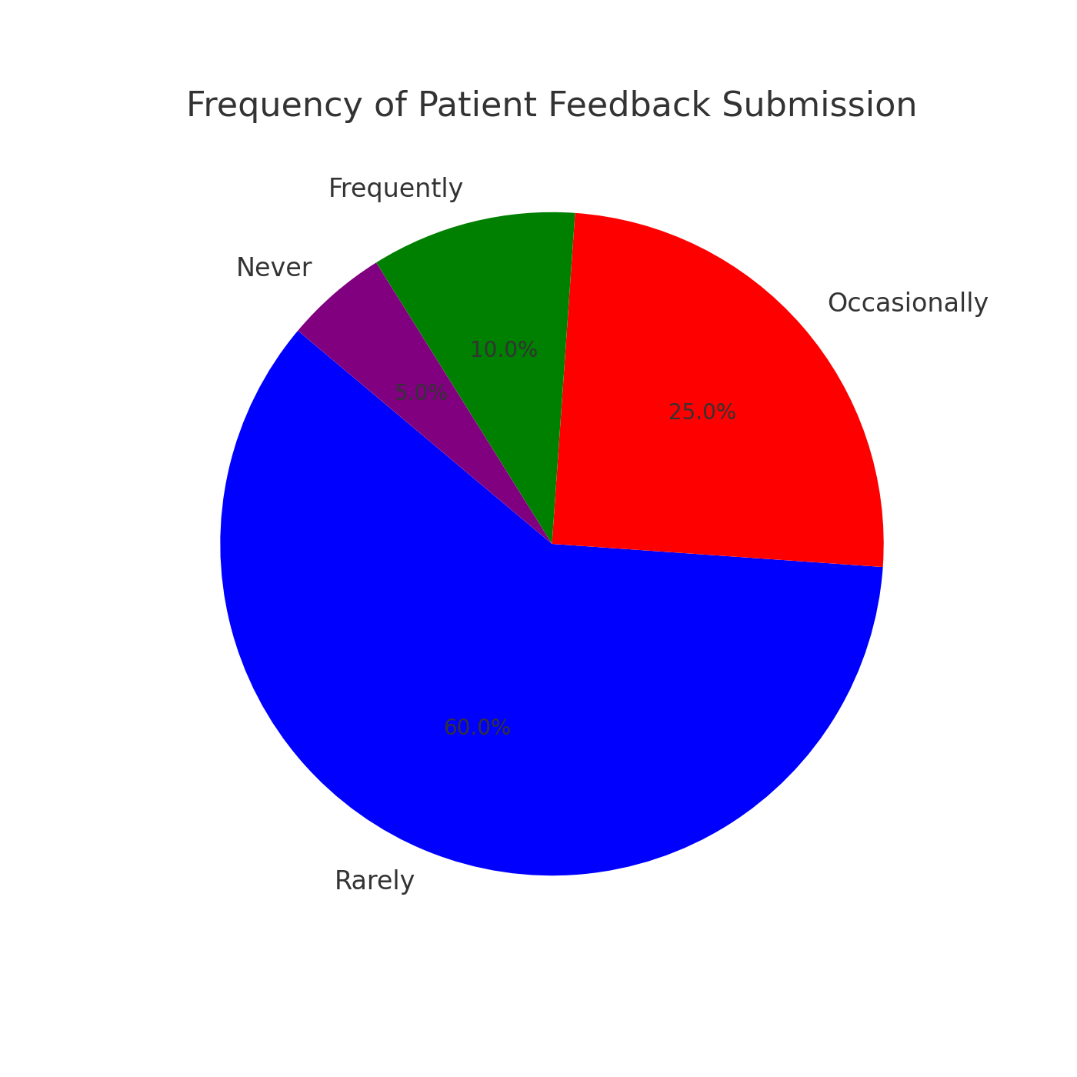

*Preferred Feedback Submission Methods*

Out of the 50 respondents, 27 preferred structured feedback options such as ratings and checkboxes due to their simplicity. Meanwhile, 15 patients preferred submitting detailed text-based feedback, while 5 favored voice feedback. The remaining 3 respondents indicated interest in video-based feeback submission.

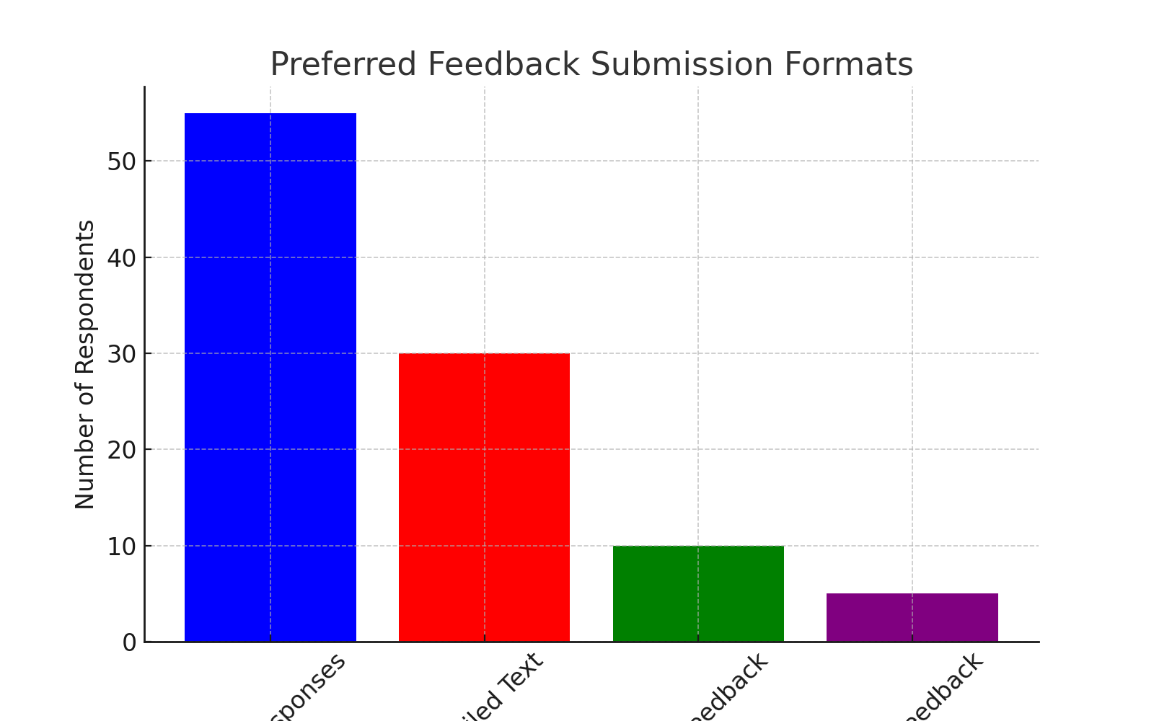

*Challenges in Current Feedback Mechanisms*

The primary challenge patients faced was the time-consuming nature of feedback submission, reported by 18 respondents. Additionally, 15 patients mentioned difficulties navigating feedback forms. Language barriers were a concern for 10 respondents, while 7 participants expressed concerns about anonymity when providing feedback.

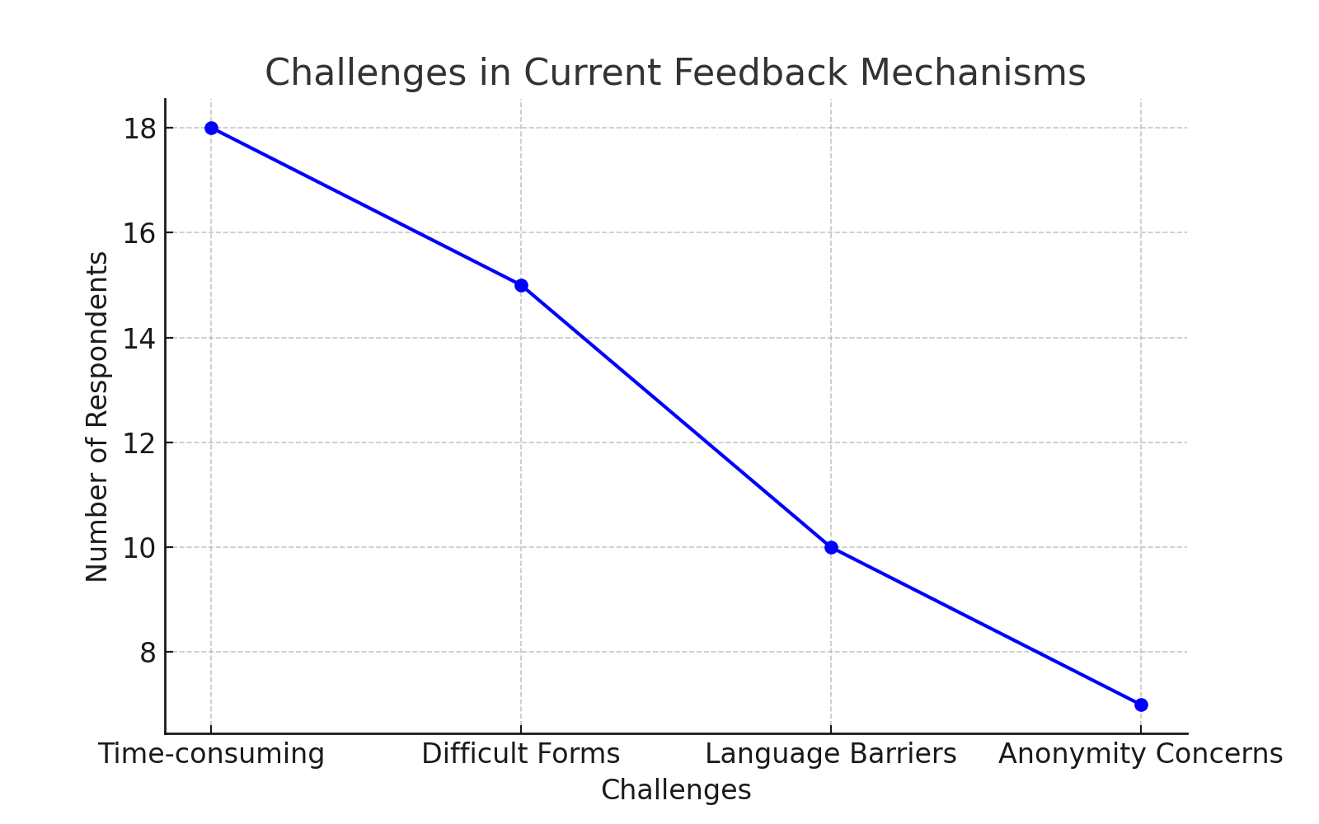

### 3.5.3 Observational Findings

Observations conducted at healthcare facilities revealed inefficiencies in feedback collection.

**Key Findings from Observations:**

*Feedback Submission Trends:*

It was observed that a significant number of patients ignored paper-based feedback forms due to time constraints, leading to a lower rate of feedback collection. Electronic feedback systems were also underutilized, primarily due to a lack of awareness among patients and healthcare providers. Additionally, there was no centralized system in place to store and analyze feedback trends, making it difficult for healthcare facilities to track recurring issues and improve services accordingly.

*Patient Willingness to Provide Feedback:*

From the observational study, it was noted that only 20 patients out of 50 voluntarily provided feedback when given the opportunity, while the remaining 30 either ignored or were hesitant to participate in the process. This highlights the need for a system that simplifies and encourages patient engagement in providing feedback.

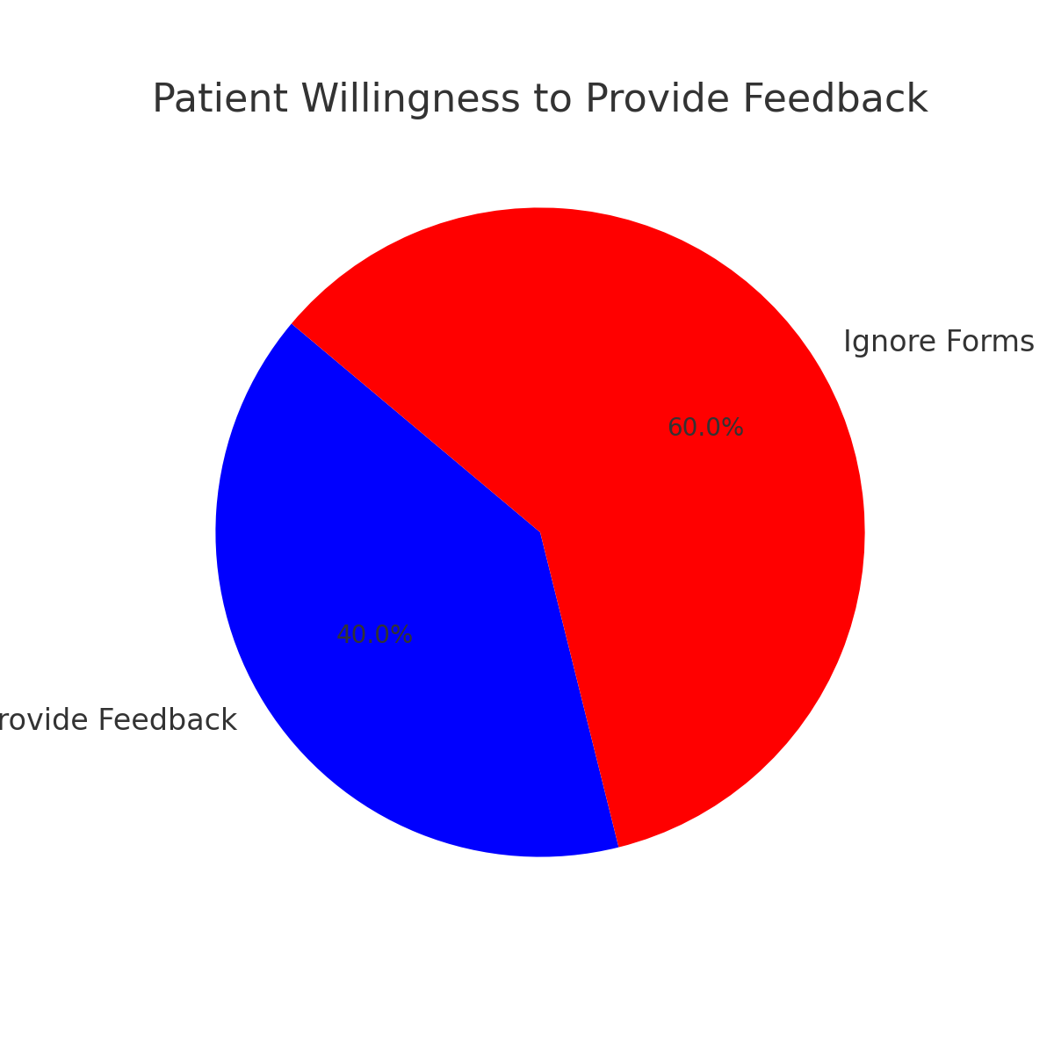

The findings from the interviews, questionnaires, and observations emphasize the need for an accessible, user-friendly, and real-time patient feedback management system, aligning with the proposed solution and research objectives.

## 3.6 System Specification

### Overview

The Patient Feedback Management System (PFMS) is designed to streamline the process of collecting, analyzing, and responding to patient feedback within healthcare facilities. To ensure the system meets operational, performance, and security requirements, this section provides a detailed specification of its functional and non-functional requirements, as well as the necessary hardware and software resources for deployment.

### Functional Requirements

The system must support a range of core functionalities that allow patients to submit feedback efficiently, administrators to manage feedback effectively, and the system to process and store data securely. The primary functional requirements include:

1. *User Authentication and Access Control* - Patients and administrators must be able to log in securely using a username and password. Role-based access control will ensure that patients can submit feedback while administrators can review and manage it.
2. *Feedback Submission* - Patients must have the ability to submit feedback in different formats, including text, voice recordings, and rating scales. The system must ensure that feedback is timestamped and stored securely in the database.
3. *Feedback Management and Categorization* - Administrators should be able to view, categorize, and filter feedback based on criteria such as urgency, department, or type (e.g., complaints, suggestions, or compliments).
4. *Automated Feedback Notifications* - Patients should receive real-time notifications via email or SMS whenever their feedback has been reviewed or responded to by an administrator.
5. *Data Analytics and Reporting* - The system must generate customized reports on patient satisfaction trends, frequently reported issues, and administrator response times. These reports should be accessible via an interactive dashboard.
6. *System Security and Data Privacy* - The system must encrypt all sensitive patient feedback and ensure compliance with healthcare data protection regulations such as HIPAA (Health Insurance Portability and Accountability Act).

### Non-Functional Requirements

To ensure the reliability, performance, and usability of the system, several non-functional requirements must be met.

1. *Security and Data Protection* - The system must implement end-to-end encryption (AES-256) for all stored feedback data and use JWT-based authentication for secure access control.
2. *Performance and Scalability* - The system should be capable of handling at least 10,000 feedback submissions per day with an average response time of less than 3 seconds for retrieving feedback records.
3. *Usability and Accessibility* - The user interface should be intuitive and easy to navigate, with support for multiple languages, voice input, and accessibility features such as screen readers for visually impaired users.
4. *System Availability and Reliability* - The system should have an uptime of 99.9% and include failover mechanisms such as automated database backups and cloud-based redundancy.
5. *Compliance with Industry Standards* - The system must adhere to data privacy laws such as GDPR (General Data Protection Regulation) and medical standards for healthcare IT systems.

## 3.7 Requirements Analysis and Modeling

### Overview

The Patient Feedback Management System is designed to enhance patient engagement by providing an efficient, structured, and user-friendly platform for submitting and managing feedback. To ensure the system's effectiveness, we use Unified Modeling Language (UML) diagrams to visualize its behavior, data flow, and interactions.

*This section presents five UML diagrams*

*Use Case Diagram* - Depicts system interactions.

*Activity Diagram* - Illustrates feedback submission workflow

*Sequence Diagram* - Shows interactions between users and the system.

*Class Diagram* - Defines system components and relationships.

*Entity-Relationship (ER) Diagram* - Represents the database structure.

### Use Case Diagram

The Use Case Diagram provides a high-level representation of the interactions between different system actors and the Patient Feedback Management System (PFMS). The primary actors include Patients and Administrators (Admins), each interacting with various subsystems within the system.

*Key Elements in the Use Case Diagram*

1. *Patient Interactions*

*Submits Feedback* - Patients can provide feedback about their experience, including complaints, suggestions, or compliments.

*Receives Notifications -* The system sends automated notifications when their feedback is reviewed or responded to.

1. *Admin Interactions*

*Views Feedback -* Administrators access and review submitted feedback.

*Responds to Feedback -* Admins can reply to patient feedback, providing resolutions or requesting more information.

*Analyzes Trends -* Admins use reports to identify patterns in patient feedback, such as recurring complaints or service improvements.

*Generates Reports -* The system compiles data into reports for performance tracking and decision-making.

1. *System Interactions*

*Feedback System -* Handles the collection and management of patient feedback.

*Database -* Stores all feedback securely for future reference and analysis.

*Notification System -* Sends alerts to patients when feedback is reviewed or responded to.

*Reporting System -* Processes and analyzes feedback trends, generating reports for administrators.

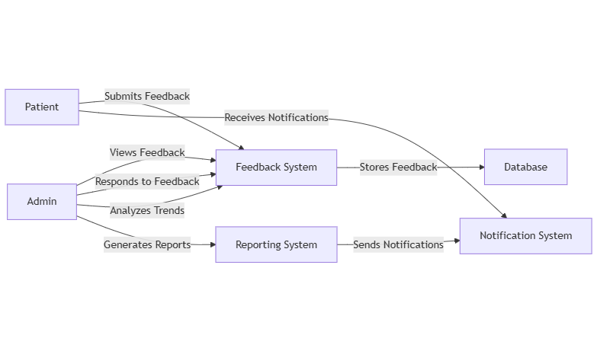

**Use Case Diagram for the Patient Feedback Management System**

### Activity Diagram

The Activity Diagram describes the workflow of submitting and managing feedback. It shows the step-by-step process from when a patient submits feedback to when an admin reviews and responds.

Key Steps in the Activity Diagram

1. Patient logs into the system.
2. Patient submits feedback (text, voice, or rating).
3. System stores feedback in the database.
4. Admin reviews and categorizes feedback.
5. Admin responds or takes further action.
6. Patient receives notification of the response.

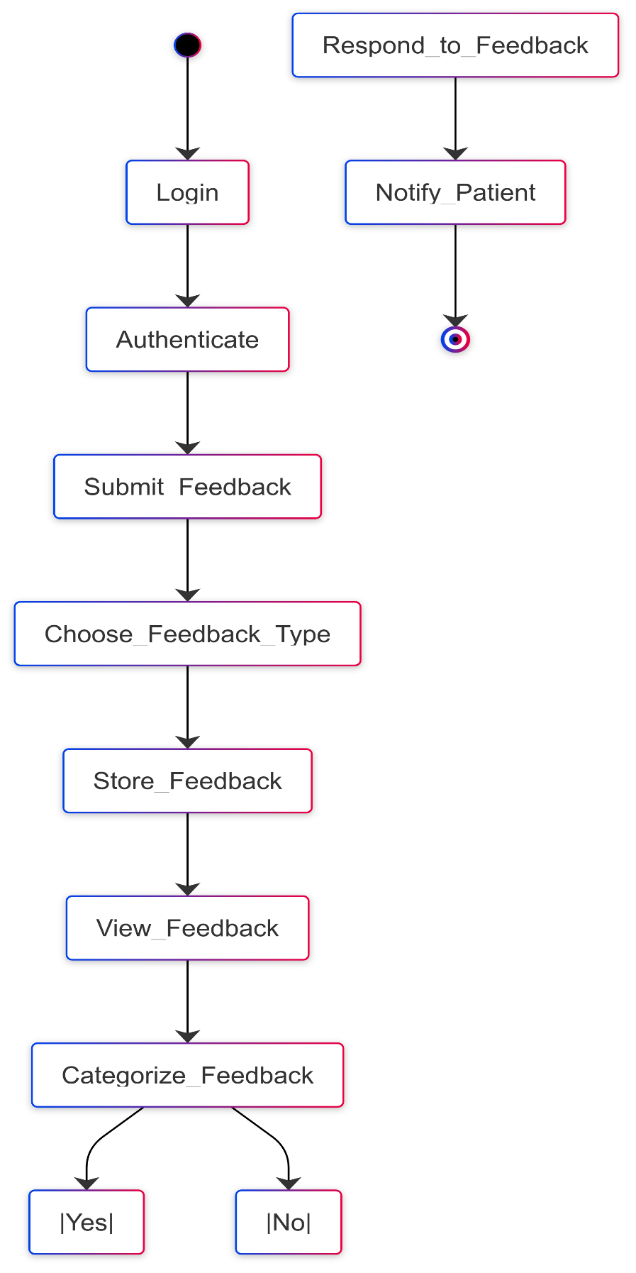

**Activity Diagram for the Patient Feedback Management System**

### Sequence Diagram

The Sequence Diagram represents the order of interactions between system components. It helps visualize how the system processes feedback submissions, authentication, and responses.

#### Actors

*Patient* - Submits feedback and receives responses.

*System* - Processes user authentication, feedback storage, and communication.

*Database* - Stores and retrieves feedback and responses.

*Admin* - Reviews feedback and provides responses.

#### Process Flow

1. *Patient Login*

The patient initiates login.

The system sends authentication details to the database for verification.

If authentication succeeds, the system notifies the patient of a successful login.

1. *Submitting Feedback*

The patient submits feedback via the system.

The system stores the feedback in the database.

1. *Admin Retrieves Feedback*

The admin requests feedback data from the system.

The system retrieves feedback from the database and sends it to the admin.

1. *Admin Responds to Feedback*

The admin submits a response to the feedback.

The system stores the response in the database.

1. *Notifying the Patient*

The system notifies the patient that a response is available.

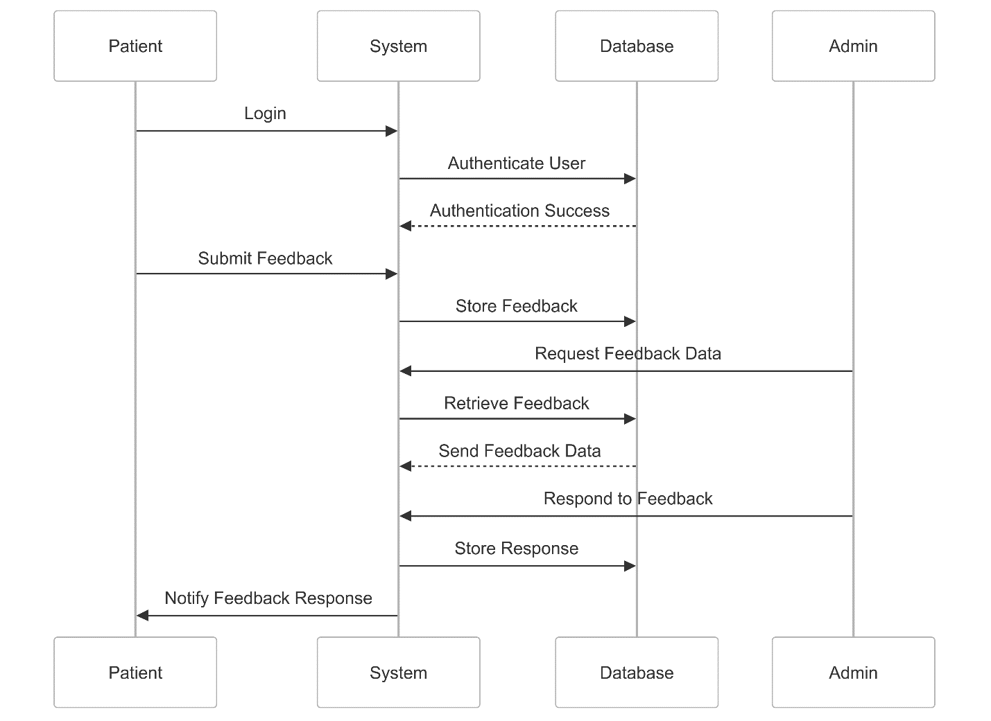

**Sequence Diagram for the Patient Feedback Management System**

### Class Diagram

The Class Diagram defines the system’s main entities and their attributes/methods. It provides a blueprint for the system's object-oriented structure.

Key Classes in the Class Diagram

*Patient* - Holds patient details and feedback submissions.

*Admin* - Manages and responds to feedback.

*Feedback* - Stores content, submission date, and response.

*System* - Handles authentication and notifications.

# 

# 

**Class Diagram for the Patient Feedback Management System**

### Entity-Relationship (ER) Diagram

The Entity-Relationship (ER) Diagram represents the structure of the Patient Feedback Management System (PFMS), defining the entities, attributes, and relationships within the system. The diagram provides a clear view of how patients, feedback, admins, and responses interact.

#### Entities and Attributes

1. *Patients*

This entity represents the users (patients) submitting feedback.

patientID (int, PK) -Unique identifier for each patient

name (string) - Patient’s full name

email (string) - Patient’s email address

1. *Feedback*

This entity stores the feedback submitted by patients.

feedbackID (int, PK) - Unique identifier for each feedback entry

patientID (int, FK) - Foreign key linking to the Patients table

content (text) - The actual feedback message

dateSubmitted (date) - Date when the feedback was submitted

1. *Admins*

This entity represents system administrators who manage the feedback system.

adminID (int, PK) - Unique identifier for each admin

name (string) - Admin’s full name

email (string) - Admin’s email address

1. *Responses*

This entity stores responses to patient feedback, provided by admins.

responseID (int, PK) - Unique identifier for each response

feedbackID (int, FK) - Foreign key linking to the Feedback table

adminID (int, FK) - Foreign key linking to the Admins table

responseText (text) - The response content

dateResponded (date) - Date when the response was sent

#### Relationships

1. *A patient submits feedback*

One-to-Many Relationship (A patient can submit multiple feedback entries, but each feedback belongs to only one patient).

Primary Key - patientID (Patients)

Foreign Key - patientID (Feedback)

1. *A feedback entry receives a response*

One-to-One or One-to-Many Relationship (Each feedback may receive a response, and an admin can respond to multiple feedback entries).

Primary Key - feedbackID (Feedback)

Foreign Key - feedbackID (Responses)

1. *An admin manages responses*

One-to-Many Relationship (An admin can provide multiple responses, but each response is linked to only one admin).

Primary Key - adminID (Admins)

Foreign Key - adminID (Responses)

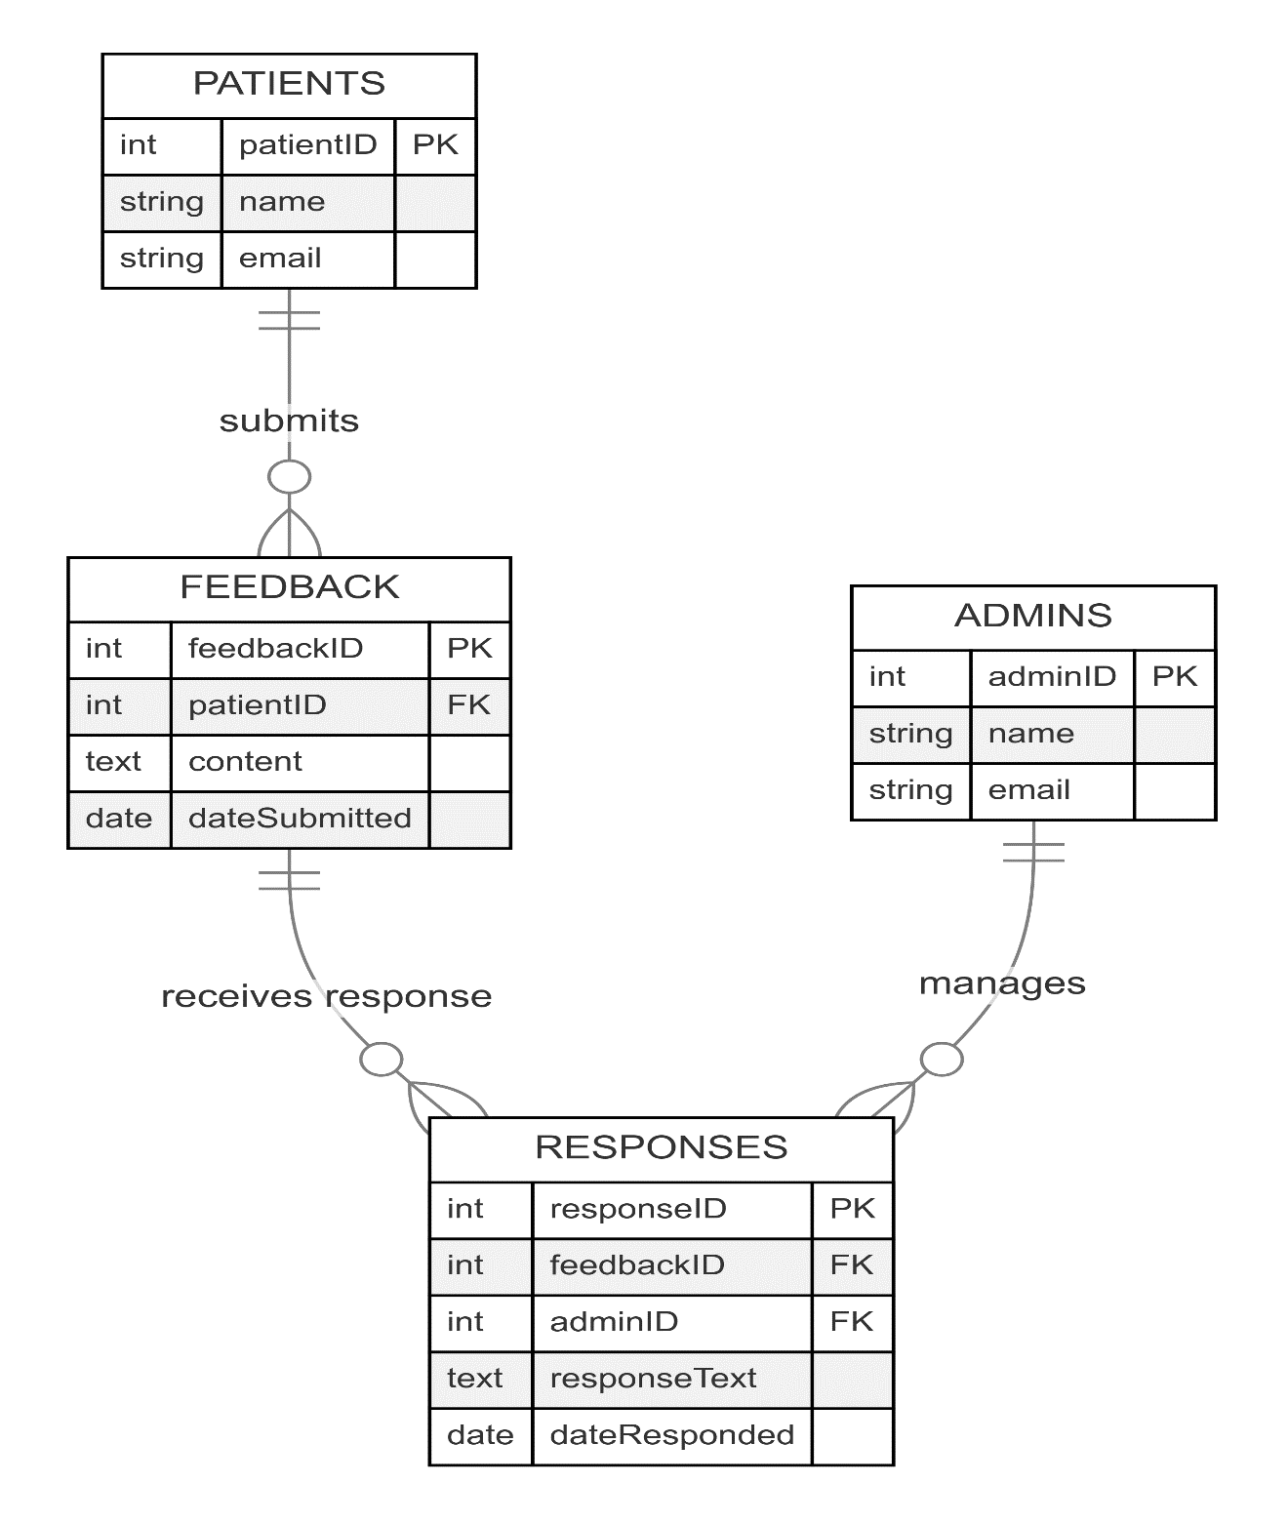

**Entity-Relationship Diagram for the Patient Feedback Management System**

# References

Davis, F. D. (1989). Perceived Usefulness, Perceived Ease of Use, and User Acceptance of Information Technology. MIS Quarterly, 13(3), 319-340.

Gómez, M., et al. (2020). Accessibility and Usability of Health Information Systems: A Review of Current Literature. Health Informatics Journal, 26(3), 1789-1801.

Hodgkinson, M., et al. (2018). Privacy and Security Considerations in Patient Feedback Systems. Journal of Medical Internet Research, 20(8), e10272.

Hussein, M., et al. (2017). Designing a Mobile Patient Feedback System for Primary Healthcare Services. Healthcare Management Review, 42(4), 332-339.

Kuniavsky, M. (2003). Observing the User Experience: A Practitioner's Guide to User Research. Morgan Kaufmann Publishers.

Schoenfelder, T., et al. (2017). The Impact of Patient Feedback on Healthcare Quality: A Literature Review. International Journal for Quality in Health Care, 29(1), 13-21.

Vasilenko, A., et al. (2019). Improving Patient Feedback Systems: Case Study of a UK Hospital Trust. Journal of Healthcare Management, 64(6), 381-392.

Wells, G., et al. (2019). Barriers to Patient Feedback in Low-Income Settings: Insights from Kenyan Healthcare Systems. International Journal for Equity in Health, 18(1), 30.